**LAB – 5 & 6**

**Name: Amit Kumar Sahu**

**Reg. No.: 18mis7250**

**VLANS AND TRUNKS**

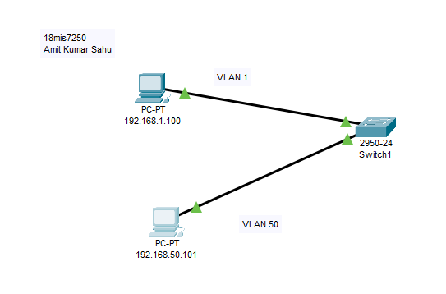

**Configuring via terminal:**

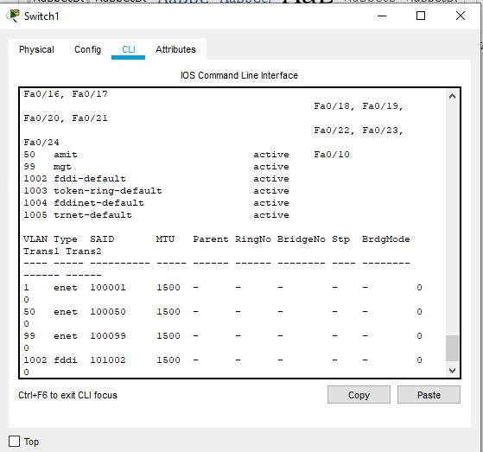

Checking by pinging device:

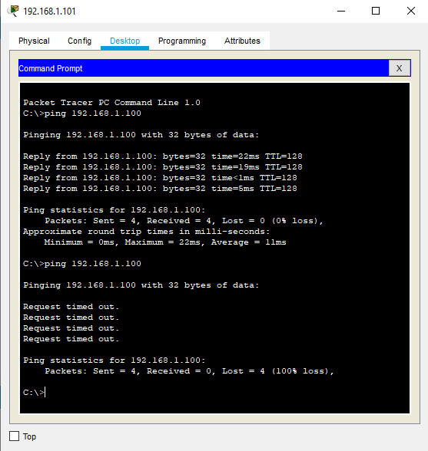

**Configuring vlan 99 mgt**

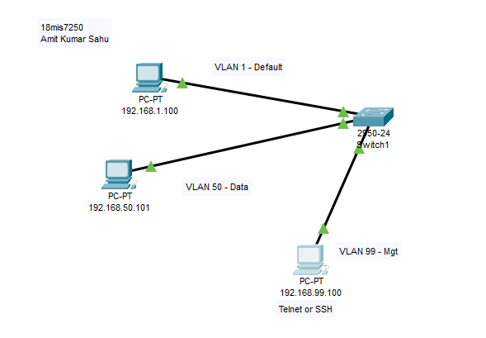

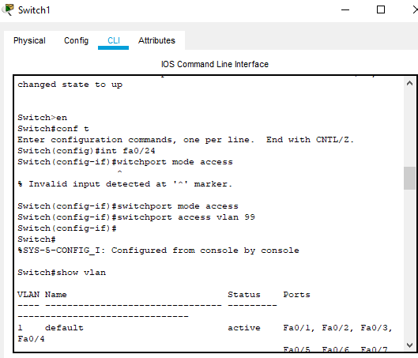

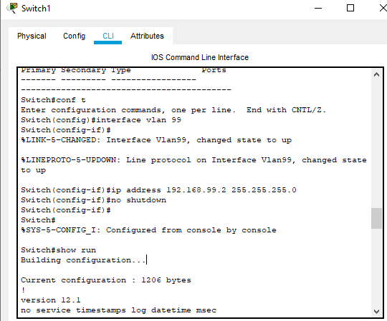

Successfully configured 192.168.99.2

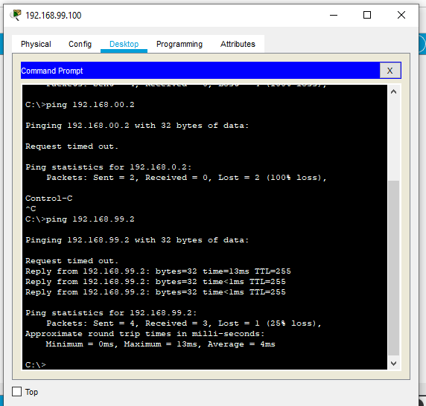

**TRUNKS**

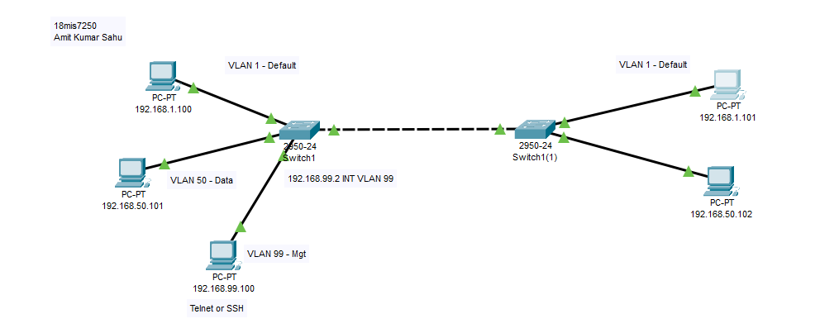

**Checking connection**

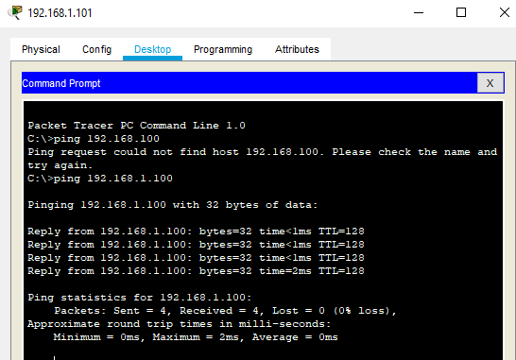

**Configuring trunk in both the switches by this command:**

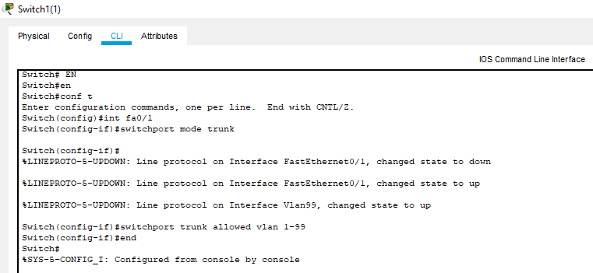

**Configured Trunk**

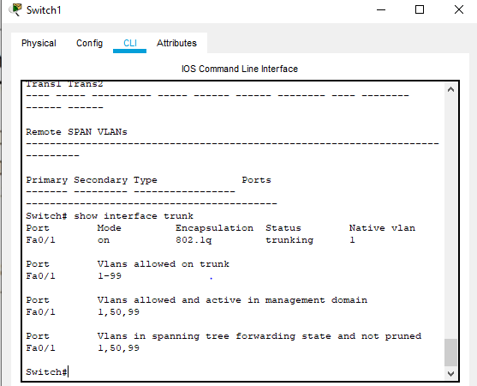

**Verifying trunk is working by pinging**

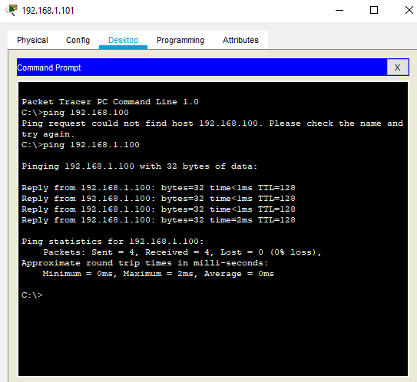

Packets Passing Successfully Via Trunk  
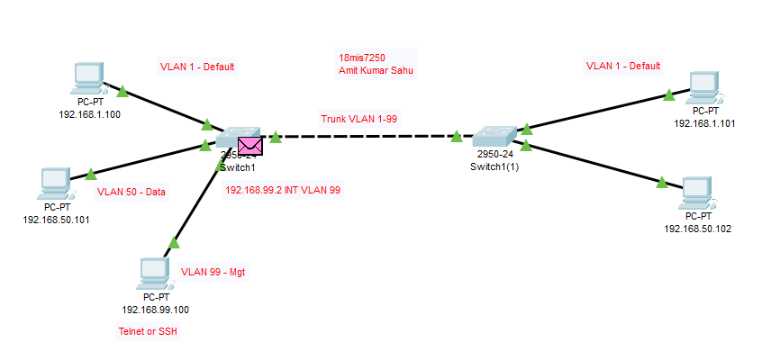

**Simple VLAN Config With Router and Switch**

